- Purpose
To define and provide guidelines and instructions for selecting and approving contract suppliers who provide materials and services.

- Scope
This procedure applies to the qualification of all contractors for GCP, GLP, GMP or other services that directly affect the quality of EPIC products.

- Definitions
Contractor | Any supplier that on contract provides materials or services.
GCP | Good Clinical Practices
GLP | Good Laboratory Practices
GMP | Good Manufacturing Practices
Confidentiality Agreement/NDA | Agreement between EPIC Research & Diagnostics, Inc. and Contract Supplier or other service provider that binds each to confidentiality.
Request for Proposal | Document produced by EPIC Research & Diagnostics, Inc. explaining the products or services required of a Contract Supplier.
Approved Supplier | A supplier that has been approved through EPIC’s Supplier Qualification procedure .
Audit | An evaluation of a supplier’s quality system including procedures, policies and records. Typically either an on-site audit (at the supplier’s facility) or from a self-survey form that is sent to the supplier, completed by them and returned to EPIC.

- Responsibilities
User | - Complies with the policy and procedure for all new or revised documents.  - Ensures the most current version of this document is used when referenced.
Departmental Management | - Ensures departmental personnel are properly trained before using this policy or procedure.  - Provides a timely review and approval/rejection of a draft document.
Quality Assurance | - Complies and enforces the document control standards within this document.  - Monitors the implementation and effectiveness of this document.  - Assists Users and Departmental Management with writing/revising documents.

- Policy
  - All contract suppliers and consultants will agree to and execute a contract with EPIC before providing any products or performing any services.
  - All contact suppliers and consultants will agree to and execute a Confidentiality Agreement/NDA with EPIC before discussing confidential information.

- Procedure
  - Contractor Initiation
    - The applicable department head or designated representative performs all initial research on each supplier to establish their services, expertise, availability, and capabilities.
    - Execute a Confidentiality Agreement/NDA and if necessary a Request for Proposal/Quote (RFP/Q).
    - Notify Quality Assurance (QA) when the above documentation is in place and provide supplier’s contact information.

  - Contractor Prequalification
    - Verify an NDA has been executed before discussing any confidential information with the supplier.
    - Using the provided company information, contact the supplier representative and request the following documents be completed and/or forwarded to EPIC as applicable:
      - Confidentiality Agreement/NDA
      - Supplier Quality Questionnaire or Clinical Service Provider Questionnaire
      - Supplier Operating Information
        - SOP Index
        - Organizational Chart
        - Facility Diagram
        - Scope of Services Provided
        - Approved Subcontractor List for performing any outside services on EPIC projects
      - Supply Agreement
      - Quality Agreement
      - External Audit
      - ISO Certification
    - All documentation collected to support supplier qualification is clearly recorded on the Supplier Qualification Record with appropriate signatures and dates.
    - Store and maintain the supplier file alphabetically in either the Supplier Qualification files or Clinical Service Provider files.

  - Qualification Process
    - The Supplier Approval team determines the required documents necessary for each supplier to be considered for qualification as an approved contractor. Requirements may be exempted by written justification of the Supplier Approval Team. Based on the prequalification materials and information from the involved internal department, the Supplier Approval team determines the type of qualification process required for each contract supplier.
    - Review and compare the supplier’s processes, policies, and available documentation and evaluate the supplier’s level of compliance to any applicable industry standards of domestic or international governmental regulations.
    - If necessary, perform an on-site audit following QA-010, External Auditing. File the audit report in the supplier qualification file.

  - Post Qualification Process
    - Based on the documentation review and supplier on-site audit (if performed), approve or reject the supplier.
    - If approved, add the supplier to the Approved Supplier List.
    - Inform the necessary internal department(s) head or designated representative that the supplier has been either approved or rejected as a contractor.

- References
  - OPS-008, Supplier Qualification
  - OPSF-006, Supplier Quality Questionnaire
  - OPSF-008, Approved Supplier List
  - OPSF-009, Supplier Qualification Record
  - OPSF-012, Clinical Service Provider Questionnaire
  - QA-010, External Auditing

- Attachments
Attachment A – Confidentiality Agreement/NDA

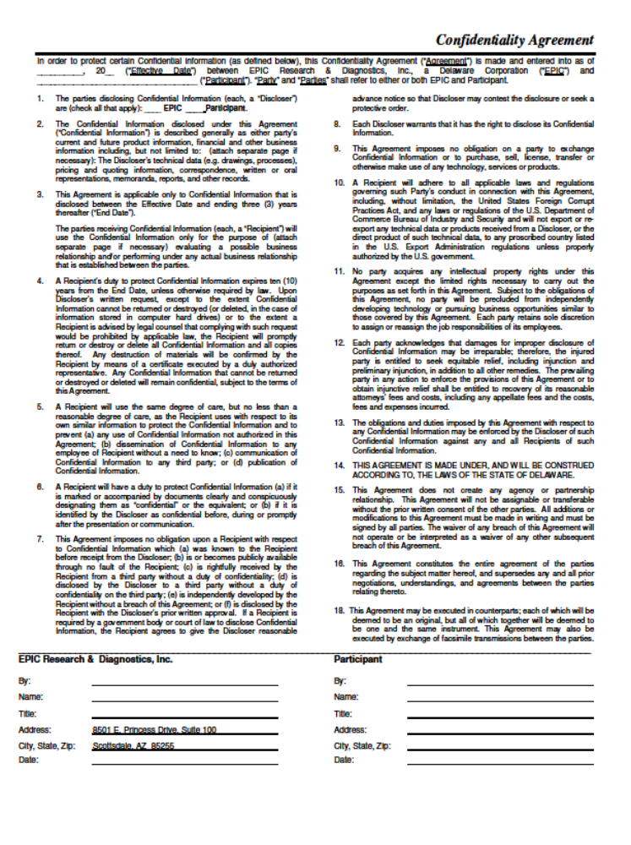

Document Revision History
Change Order Number: | Version Number: | Description of Change: | Date: | Updated by:
CC-060309-02 | 000 | New Document | 08/07/09 | T. Joiner
CC-110930-01 | 001 | Updates due to supplier qualification changes. | 10/6/11 | J. Ayres
CC-130319-01 | 002 | Addition of Supplier Qualification Record to Reference Section, reference to Supplier Qualification Record procedure, reference to supplier file management and minor edits for wording consistency. | 3/27/13 | J. Ayres

